Name:K.Rajavardhan reddy

2403A51108

Lab-9.1

Task1: Use AI to add Google-style docstrings to all functions in a  
given Python script.

Prompt:add google-style docstrimgs to all functions to the give python programm

Code:

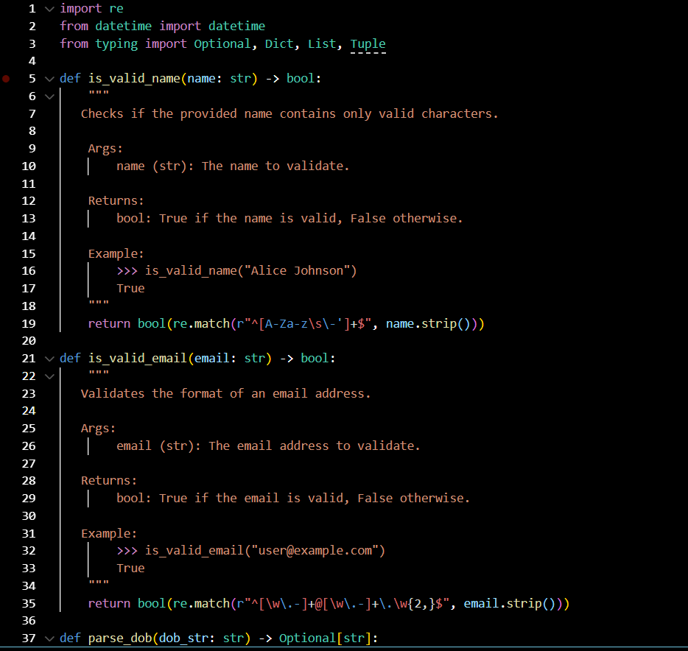

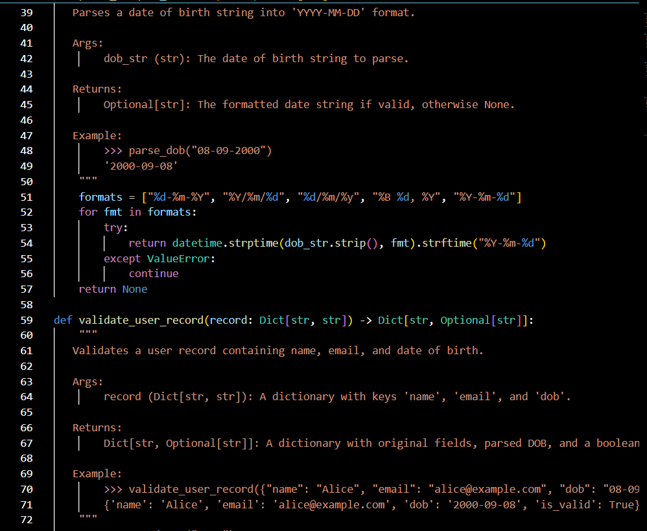

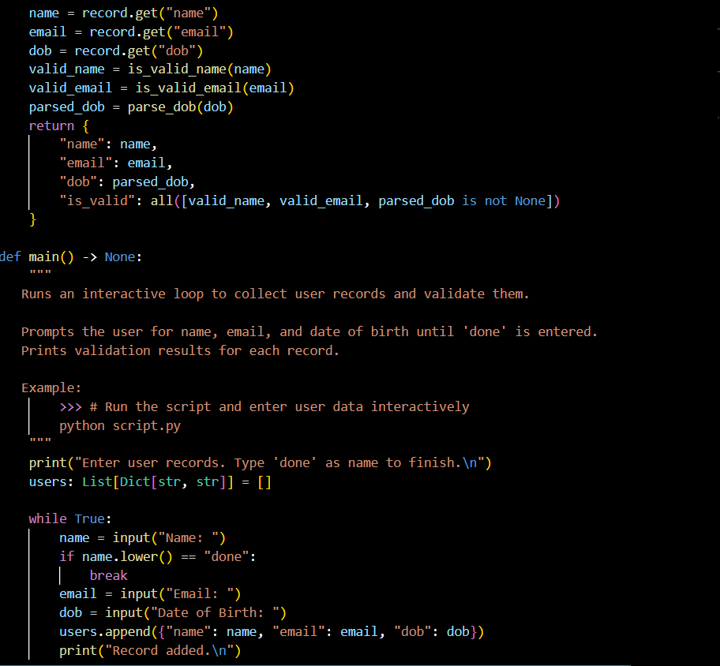

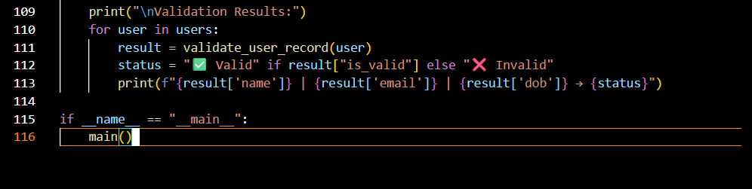

Observation:

Task2: Use AI to add meaningful inline comments to a Python  
program explaining only complex logic parts

Prompt: add meaningful inline comments to a Python  
program explaining only complex logic parts for the given programm

Code:

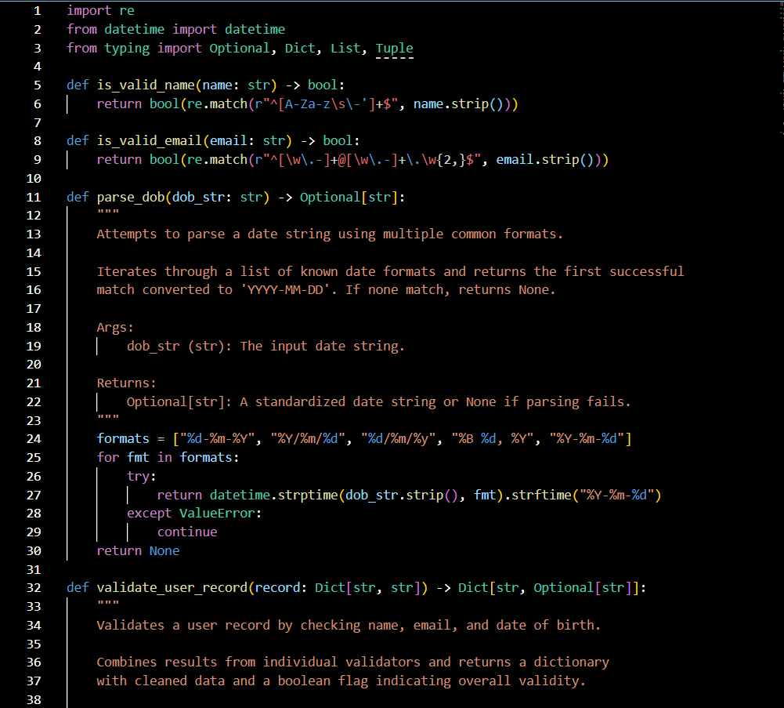

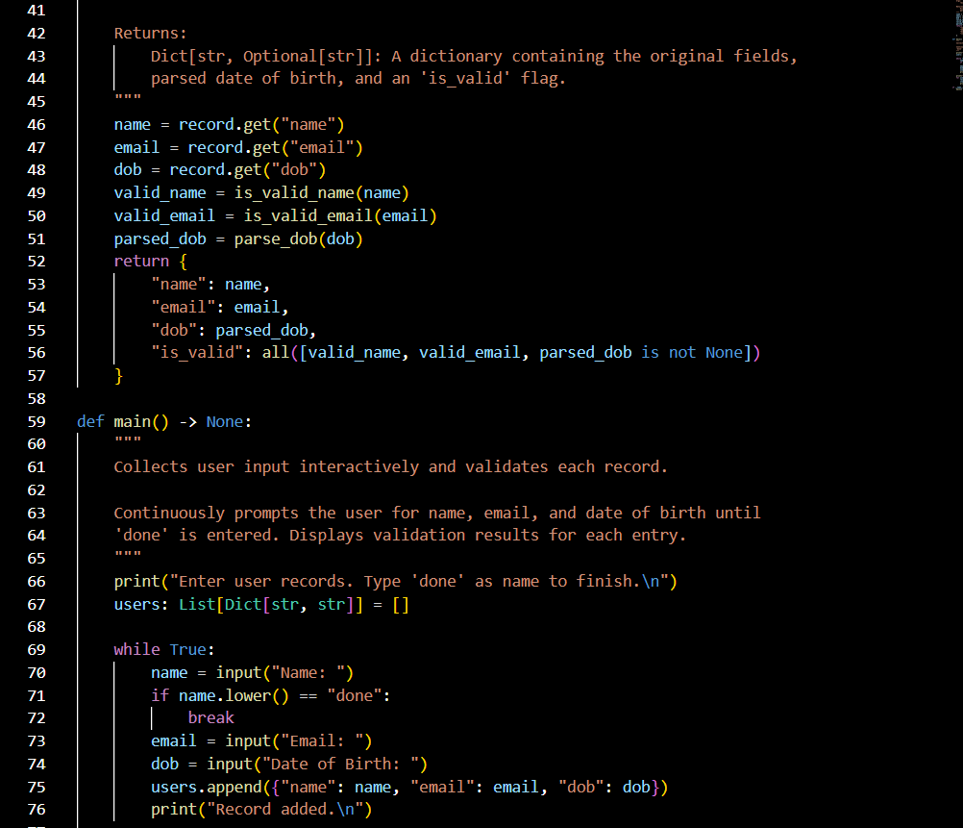

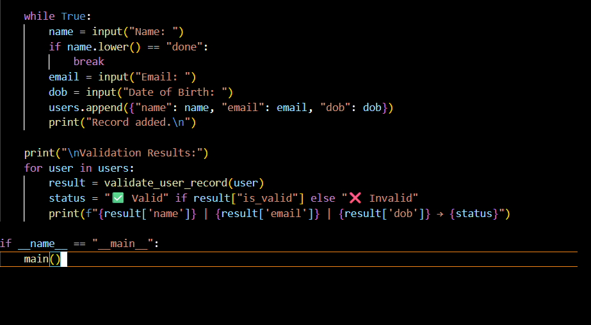

Observation:

Task3: Use AI to create a module-level docstring summarizing the  
purpose, dependencies, and main functions/classes of a Python  
file.

Prompt: create a module-level docstring summarizing the  
purpose, dependencies, and main functions/classes of a Python  
file.

Code:

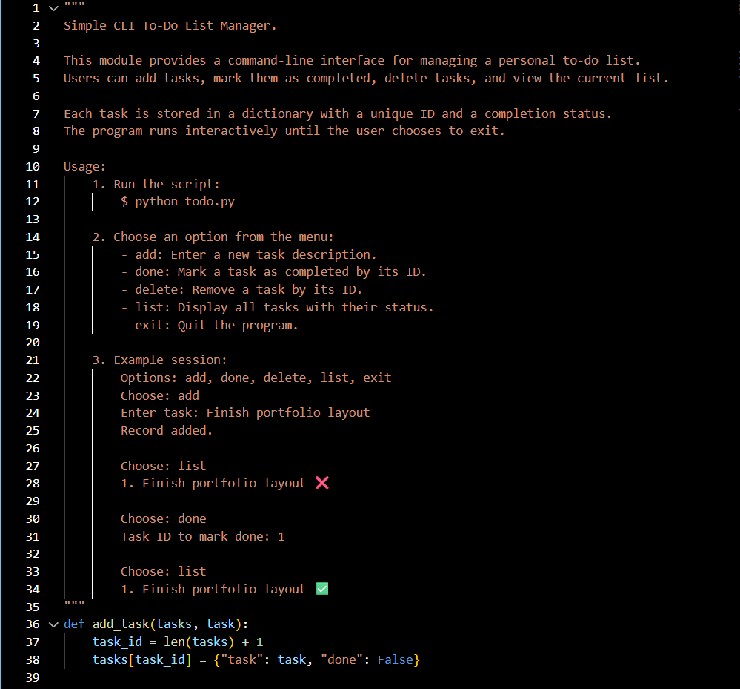

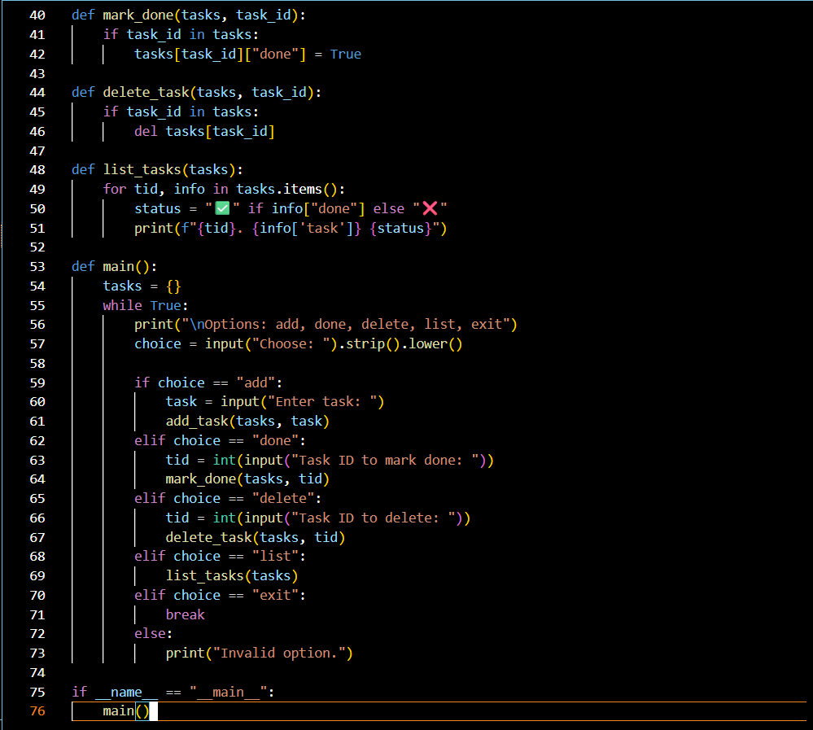

Observation:

Task4: Use AI to transform existing inline comments into  
structured function docstrings following Google style

Prompt:transform existing inline comments into  
structured function docstrings following Google style

Previous Code:

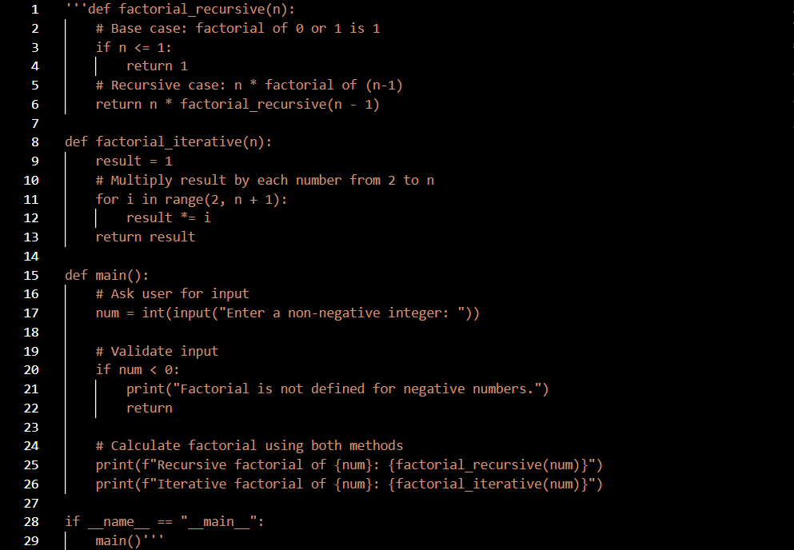

Improved:

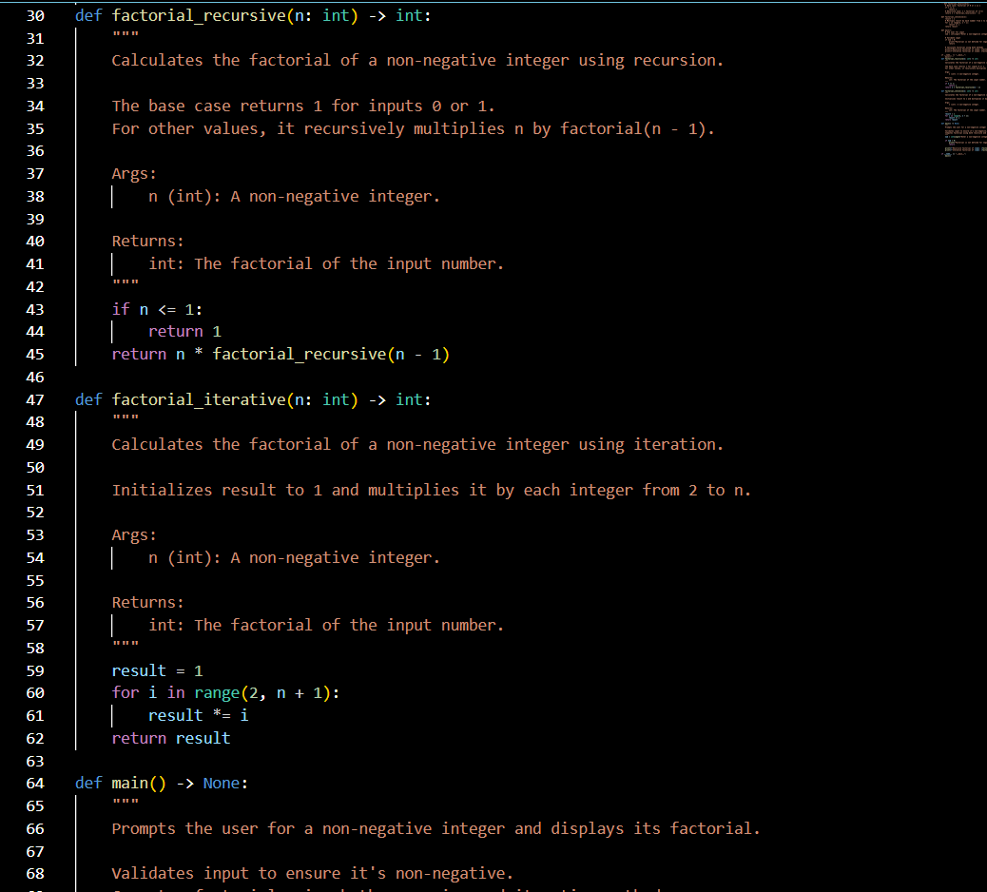

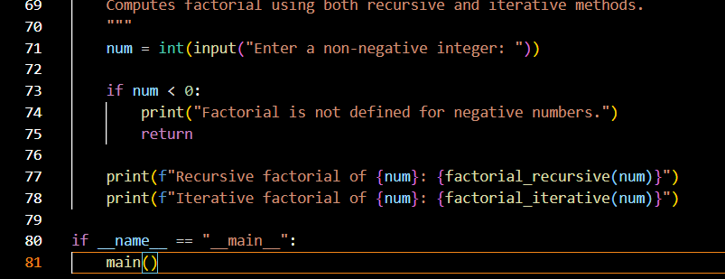

Observation:

Task5: Use AI to identify and correct inaccuracies in existing  
docstrings

Prompt:identify and correct inaccuracies in existing  
docstrings for the given code

Previous Code:

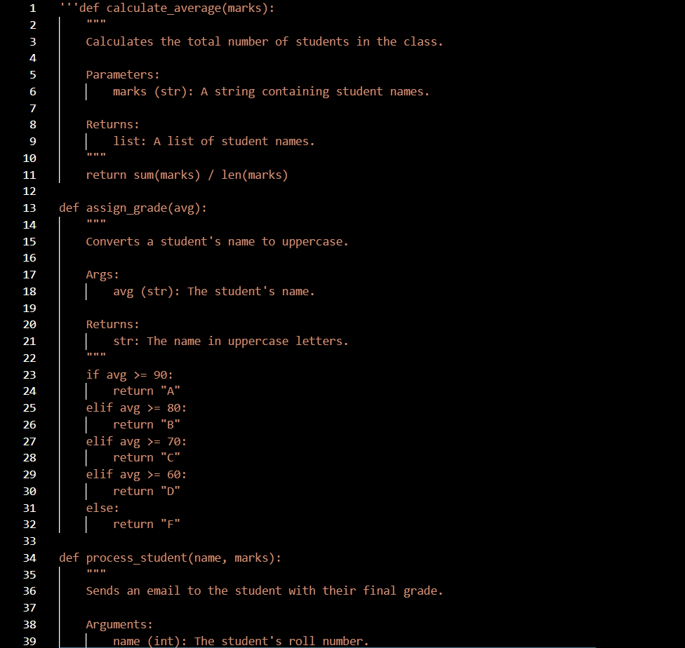

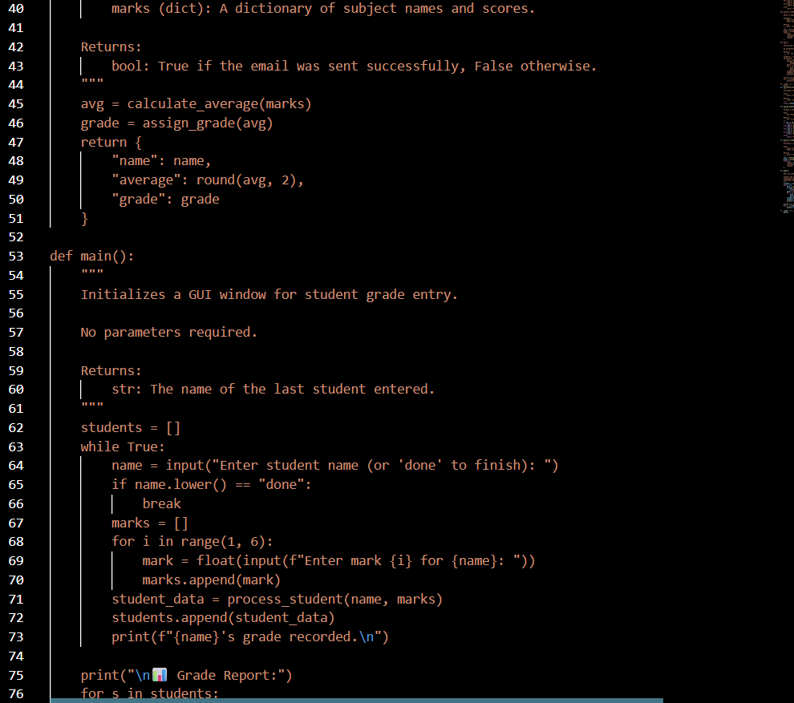

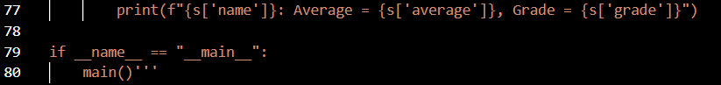

Code:

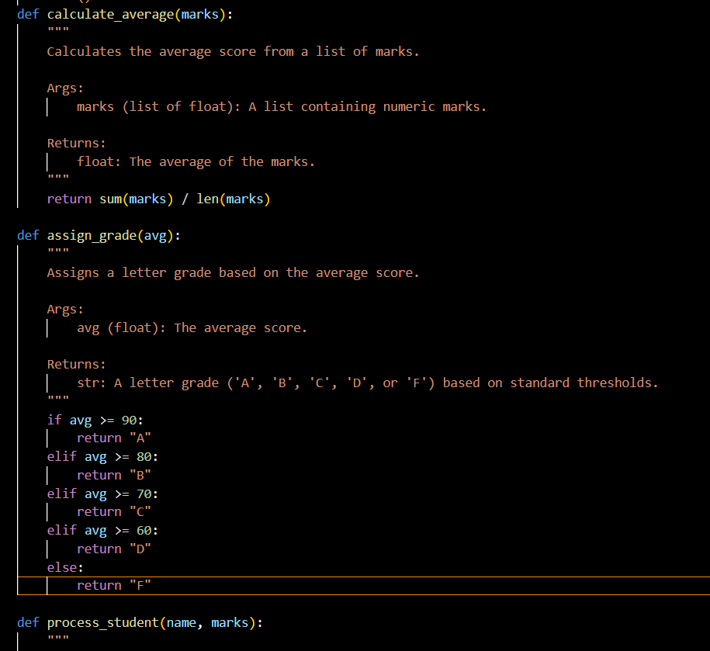

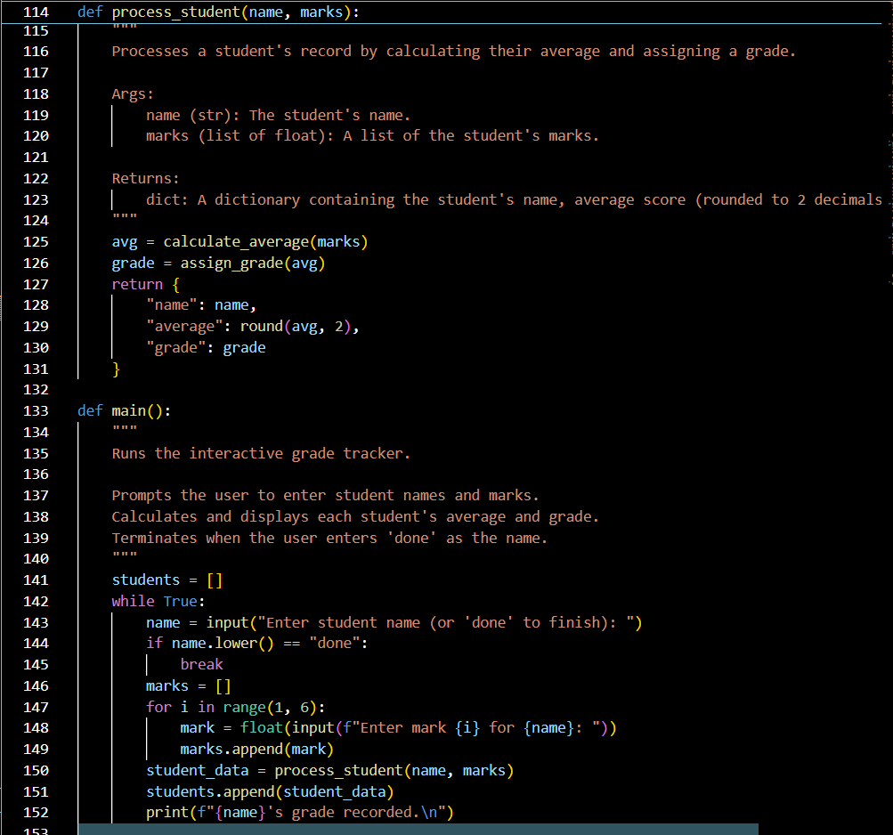

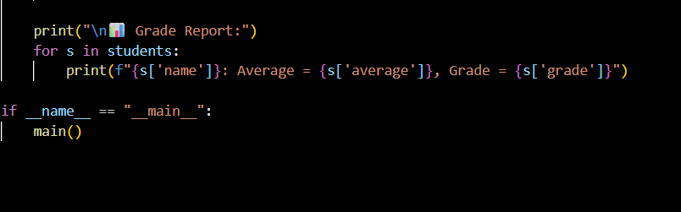

Observation: